**The Knock at the Door**

**by Stuart Mead**

1 Joey Carter was thirteen. He lived with his mother. He hadn’t seen his father for a long, long time – not since he was in kindergarten. He couldn’t remember his father’s face very well. But, at night, he could still hear him say, “Good night, Joey. I love you.”

Joey’s mother never talked about his father. There were no photographs of him

5 anywhere in the house. Joey didn’t ask about his father, but he secretly hoped his

father would return one day. He felt sure that he would.

The old house they lived in was built by Joey’s grandparents. They were dead, but Joey always felt that they were still there, watching over their house and everyone who

lived in it. He never told his mother about that. Maybe she’d think he was silly.

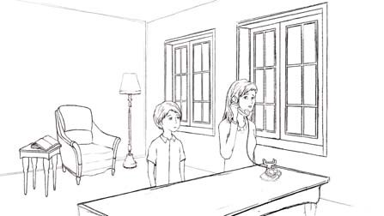

10 One stormy night, there was a telephone call. Joey’s mother answered it. She listened to the other person talking. She said nothing for a while. Then she said simply, “That’s right.” She looked worried.

15 “I have to go out,” she said. She didn’t even look at Joey.

She put on her coat and her old shoes and took her umbrella.

As she got to the front door, she turned to face Joey. “I won’t be long,” she said. “I can’t tell you where I’m going. Don’t go outside. And don’t open the door if anyone tries to

20 get in. Promise?”

Joey nodded.

She left quickly. The door closed behind her with a bang.

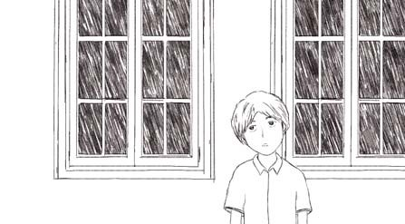 It was all so fast – the phone call, the goodbye, the promise, the closed door.

25 Joey didn’t know what to think. He just stood in the middle of the room. All around outside, the storm was a raging beast. The rain lashed against the house and the wind howled.

30 BANG! Something hard hit the roof. Joey jumped. He sat down on the sofa and held on to the book he had been reading. It was a scary story about a dead man coming back

to life and returning to his family.

The lights suddenly went out. In the darkness, the wind and rain grew louder and seemed closer.

35 Joey sat still, his heart beating fast. It made a ‘thump, thump, thump’ noise in his chest.

Where had his mother gone? And why? It was a very bad night to be outside. It was a bad night to be reading a scary story, too. In the story, there was also a storm, and an old house, and a young boy, and a …

40 BANG! Again there was a loud noise on the roof. Again Joey jumped. He held the book more tightly. The wind and the rain suddenly stopped. There wasn’t a sound. Just the dark night. Joey waited.

BRRRING! BRRRING!

The telephone!

45 Then it stopped, even before Joey had moved.

Then there was nothing. Just the darkness. The same darkness as in the story. Joey put the book down on the sofa, then got up and walked slowly to the window. He

wanted to see if the storm really had stopped. Carefully, he opened the window and looked out. There were a few lights in the distance – other houses.

50 Again: BRRRING! BRRRING!

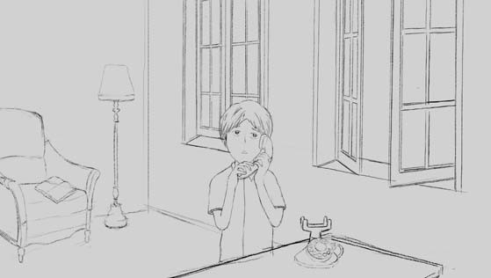 Joey ran to answer it.

“Hello.”

Nothing.

He put the phone down.

55 BRRRING! BRRRING!

Quickly he picked it up again.

“Hello. Who’s there?”

Nothing.

“Is that you, Mum?”

60 Nothing.

He put it down a second time. He waited for it to ring again. It didn’t.

 He went back to the open window. Just as he got there, a strong wind came into the house – whoosh! – blowing books,

65 magazines and other things all over the room. The book Joey had been reading was open at the page where there was a picture of the dead man who had returned on a stormy night.

70 Joey rushed to close the window. The wind was strong! He had to work hard to stand up. Then the rain came back. The wind blew the rain through the window. The rain was cold – like death – and it felt angry.

As he closed the window, he got totally wet. What would mum think? “Get some dry clothes,” he said to himself. As he passed the telephone, it rang again.

75 BRRRING! BRRRING!

When he put out his hand to pick it up, it stopped.

Then, with a ‘click!’ the lights came back on.

“Good!” Joey thought.

Then the lights went off again.

80 The BANG! on the roof again.

The BRRRING! BRRRING! again.

Then there were three knocks on the front door.

KNOCK! KNOCK! KNOCK!

“Mum!” Joey thought immediately. “But why doesn’t she come in? She has a key.”

85 Joey walked slowly and silently to the door. He put his ear up close to the door to listen.

Nothing.

He waited some more.

Nothing.

90 Then, all of a sudden, came the three knocks on the door again. They were loud, as if made by a man.

KNOCK! KNOCK! KNOCK!

Joey jumped back.

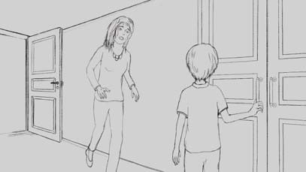 “Mum! Is that you?” he called out hopefully.

95 There was no answer from the person at the door.

He stepped forward, reaching for the door. His hand was shaking and his mouth was dry.

100 “Don’t open it! It’s him!” came a shout from behind him.

Joey’s heart almost stopped. He turned around. His mother was running across the

room towards him. She must have come in through the back door.

“Who?” he asked.

“It’s him! It’s him!” I’m sure it’s him!” his mother shouted.

105 Her clothes were wet, and her long, wet hair fell across her face. Joey thought she looked a bit crazy – or very scared.

“I told him you were alone. And I told you not to let anyone in. Oh, where is it? Where did I put it? He can’t come in yet. Not until…”

She stopped suddenly.

110 Joey looked at her, not understanding, but becoming more afraid.

“What’s happening? Who is it?” he asked.

Again there were three loud knocks on the door.

KNOCK! KNOCK! KNOCK!

It was like the dead man in the story – trying to get into the house.

115 Joey’s mother screamed, “No, no, no!”

Joey started screaming, “What? What? What?”

“Got it!” she shouted, holding up her hand with something in it.

Joey couldn’t see what she was holding. The room was too dark.

“Open the door!” she shouted.

120 “No!” Joey shouted. “It’s him!”

“I know it’s him!” his mother replied. “We have to let him in.”

“No, we don’t!” Joey said.

“He has to come in,” his mother said firmly.

“No, he doesn’t! He has to stay outside!” Joey said.

125 He was thinking about the man in the story. He knew it was him!

“Let him in!” his mother said. “I have it now.”

“Have what?” Joey asked.

“The money,” she answered.

“What money?” he said.

130 “The money for the pizza,” she explained.

Very slowly, Joey opened the door.

“Seafood pizza?” asked a very wet and very cold young man.

.....

That night, Joey and his mother sat in their dark house and ate pizza for dinner. While

they were eating, someone knocked at the door.

135 KNOCK! KNOCK! KNOCK!

**Task 3:**

**Information about Character and setting:**

In the story “The knock at the door”, there was a boy named, Joey Carter. He was 13 years old. He lived with his mother because he hadn’t seen his father for a long time. Even when he was in kindergarten. Due to this he couldn’t remember his father’s face very well. But at night, he could still hear his father saying, “Good night Joey, I love you”.

Joey Carter and his mother lived in an old house, built by his grandparents. They were dead, but just like he thought about his father same as he always felt that they were still with him. And thought they were watching the house and all the people who lived in their house. One stormy night, there was a telephone call answered by Joey’s mother. She said nothing and hearing the other person and after a while said “That’s right” and looked worried. Then she went from the home and said to Joey Don’t open the door and never go to outside I will be come back soon.

**Task 4:**

**Plot of the story:**

One stormy night, Joey’s mother goes out after she answers a phone call. She leaves Joey alone in the house. Joey does not know why his mother goes out. Joey didn't like to be alone on stormy days. He felt frightened as the rain lashed against the house and the wind howled. There is a storm outside. BANG! Something hard hit the roof. Joey was frightened as he realized he may not be alone in the house. His heart beating fast. He did not want to show he was so scared and tried to calm down. He try to laugh at how silly he was - surely, he was imagining things. Suddenly the telephone rings. Joey answers but no one is there. Then the rain comes in through the open window and Joey gets wet trying to close it. There is a knock at the door. Joey’s mother comes in through the back door and tells him not to answer it until she finds what she is looking for. When she finds it, she tells Joey to open the door but he is too frightened. Joey finally opens the door. It is the pizza delivery man. That night, Joey and his mother sat in their dark house and ate pizza for dinner. While they were eating, someone knocked at the door. KNOCK! KNOCK! KNOCK!